How to setup Sparkfun Intel ® Edison nodes

Flashing the firmware (Windows):

1. [Download](https://software.intel.com/iot/hardware/edison/downloads) Yocto image for the board.
2. Extract it to a folder where you want to setup everything.
3. Download dfu-util.exe and libusb-1.0.dll from <http://dfu-util.sourceforge.net/releases/> . Make sure these are placed in the same folder that you made in step 2.
4. Navigate to the folder and copy the location from the top of the file navigator.

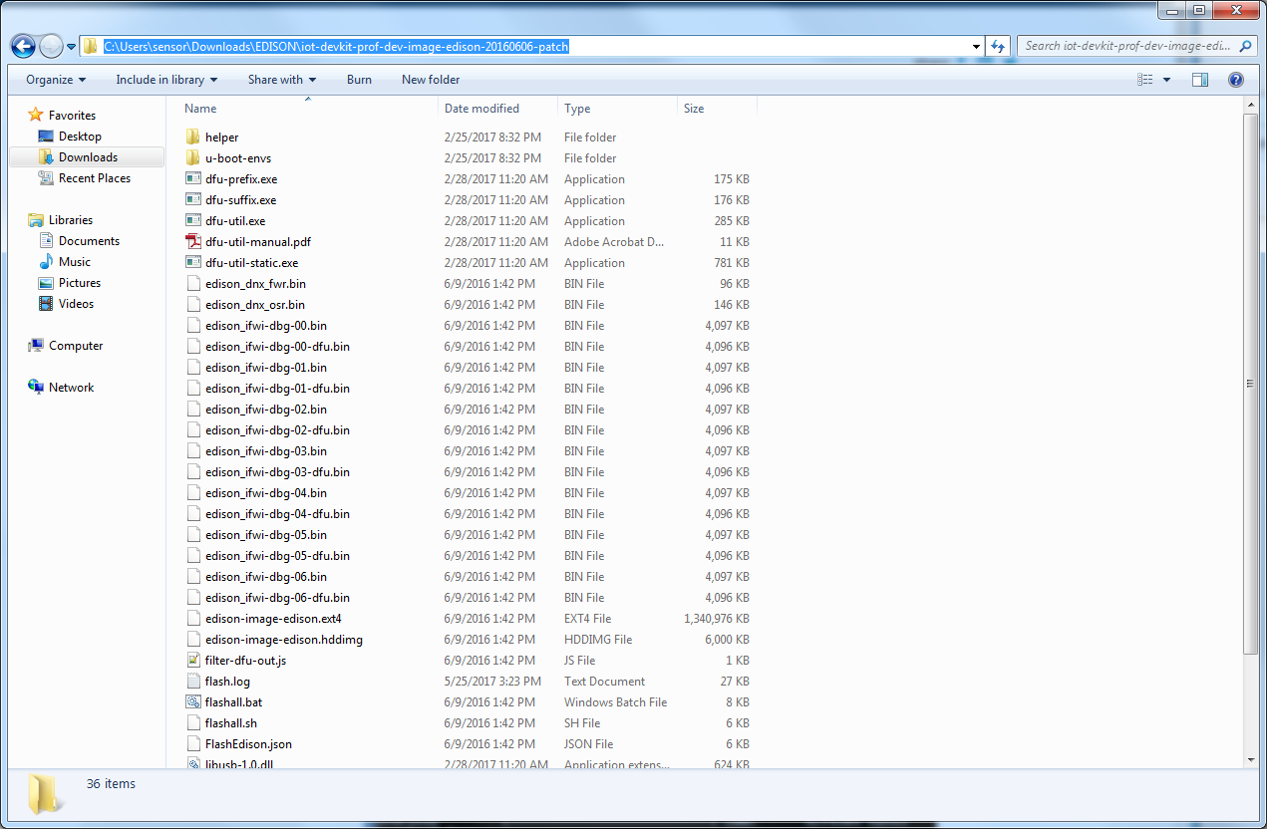

1. Open the Windows command prompt and type “cd” and paste the location you copied and hit enter.

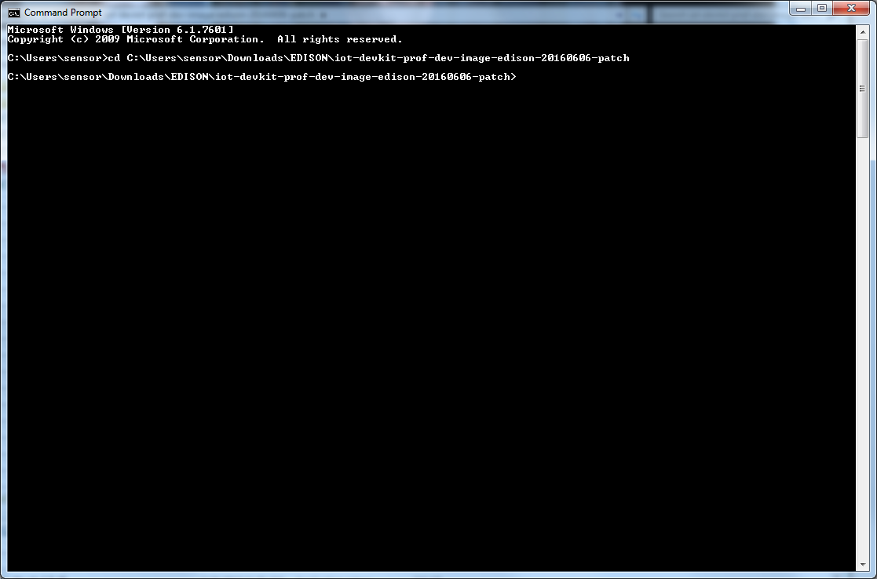

1. Connect both Micro-USB connectors to the “Console” and “OTG” ports on the Edison Stack.

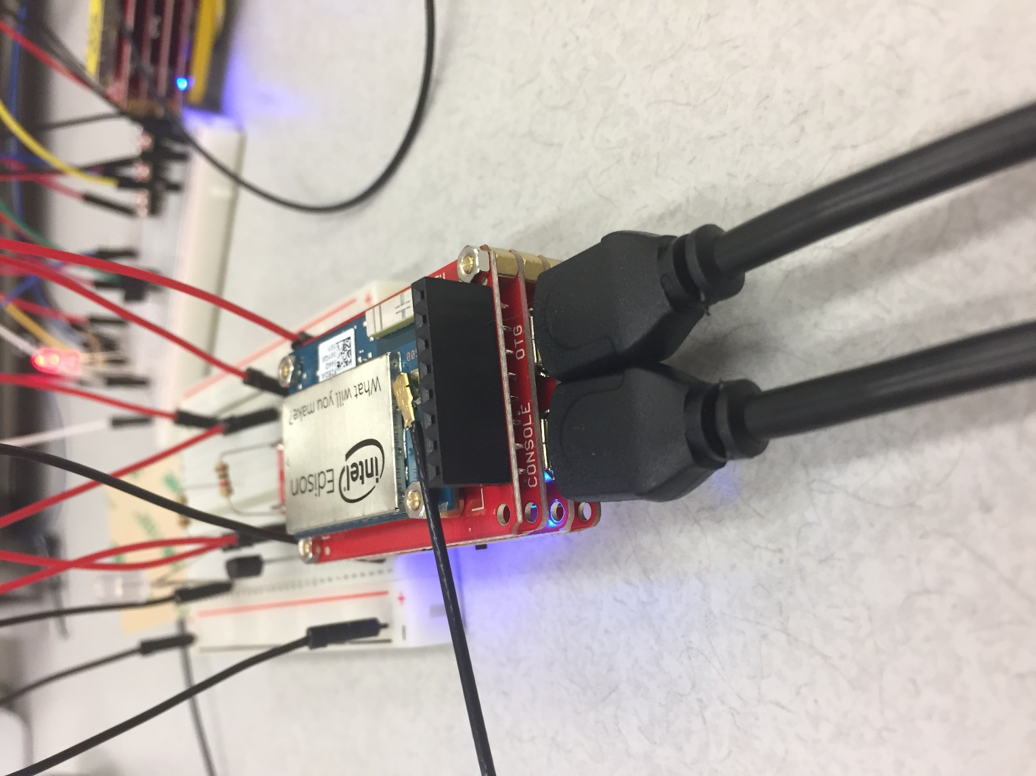

1. Open the Intel XDK and connect to your node through the serial interface at the bottom.

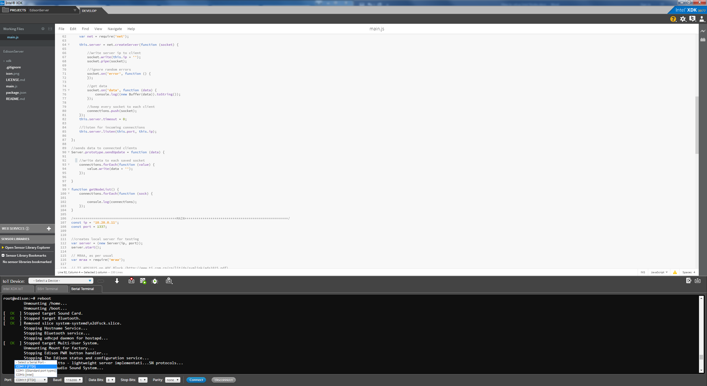

1. 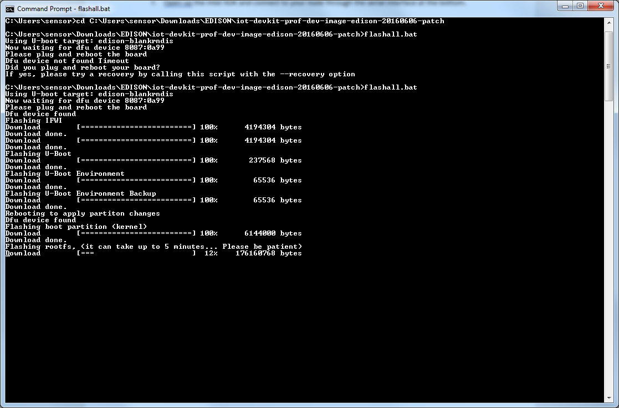Go back to the command prompt and type “flashall.bat” and hit enter. You should see something like this.
2. 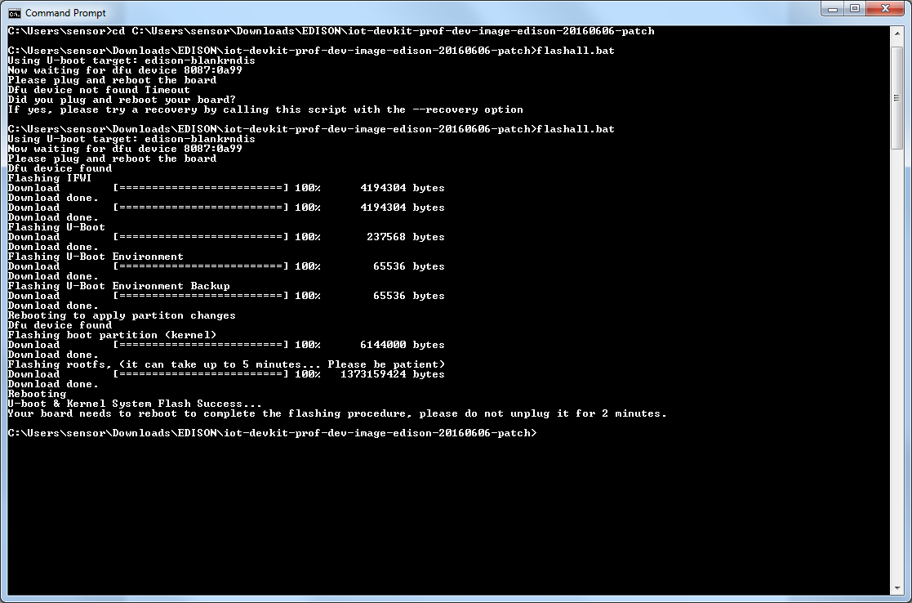Go back to the Intel XDK and type “reboot” and now the command prompt should look like this.

The process should take around 5-10 minutes. DO NOT UNPLUG THE DEVICE!!!

Setup Node/Network

configure_edison --setup

//enter password

Give this Edison a unique name.

This will be used for the access point SSID and mDNS address.

Make it at least five characters long (leave empty to skip): NAME

Is edison04 correct? [Y or N]: y

Do you want to set up wifi? [Y or N]: n

Done.

//disable power management

root@edison:~# cd /lib/systemd/system

root@edison:/lib/systemd/system# nano wifi-power-management-off.service

//paste this into the editor

[Unit]

Description=Disable power management for wlan0

Requires=sys-subsystem-net-devices-wlan0.device

After=sys-subsystem-net-devices-wlan0.device

[Service]

Type=oneshot

ExecStart=/sbin/iwconfig wlan0 power off

//Ctrl-o Enter Ctrl-x

root@edison:/lib/systemd/system# iwconfig wlan0 power off

root@edison:/lib/systemd/system# systemctl start wifi-power-management-off

//setup network

root@edison:/lib/systemd/system# wpa_cli -iwlan0 remove_network all

OK

root@edison:/lib/systemd/system# wpa_cli save

Selected interface 'wlan0'

OK

root@edison:/lib/systemd/system# systemctl start connman

root@edison:/lib/systemd/system# systemctl enable connman

ln -s '/lib/systemd/system/connman.service' '/etc/systemd/system/multi-user.target.wants/connman.service'

root@edison:/lib/systemd/system# connmanctl

connmanctl> scan wifi

Scan completed for wifi

connmanctl> services

TP-LINK_3BED wifi_00aefa09a3c4_54502d4c494e4b5f33424544_managed_psk

//setup static ip

//usage: connmanctl>config <service> --ipv4 off

connmanctl>config wifi_00aefa09a3c4_54502d4c494e4b5f33424544_managed_psk --ipv4 off

connmanctl> agent on

Agent registered

//usage connmanctl>config *<service>* --ipv4 manual *<ip_address> <netmask> //<gateway>*

connmanctl>config wifi_00aefa09a3c4_54502d4c494e4b5f33424544_managed_psk--ipv4 manual *10.20.0.x 255.0.0.0 10.20.0.1*

connmanctl> connect wifi_00aefa09a3c4_54502d4c494e4b5f33424544_managed_psk

*//input passphrase for wifi*

*//crtl+c*

root@edison:/lib/systemd/system# wpa_cli -iwlan0 save

*//modify wpa_client_actions.sh*

root@edison:/lib/systemd/system# cd /etc/wpa_supplicant/

root@edison:/etc/wpa_supplicant# nano wpa_cli-actions.sh

*//comment out*

*# ifconfig $IFNAME 192.168.15.13 netmask 255.255.0.0*

*# route add default gw 192.168.0.1*

*//And add*

*ifconfig $IFNAME 10.20.0.13 netmask 255.0.0.0*

*route add default gw 10.20.0.1*

//Now you have successfully setup the network